**WEEK-2**

**MODULE -3**

**PL/SQL PROGRAMMING**

**SUPERSET ID:6407550**

**Exercise:7-Packages**

**Scenario:1**

**Package Specification**

CREATE OR REPLACE PACKAGE CustomerManagement IS

PROCEDURE AddCustomer(p_ID NUMBER, p_Name VARCHAR2, p_DOB DATE, p_Balance NUMBER);

PROCEDURE UpdateCustomer(p_ID NUMBER, p_Name VARCHAR2);

FUNCTION GetCustomerBalance(p_ID NUMBER) RETURN NUMBER;

END CustomerManagement;

/

**Package Body**

CREATE OR REPLACE PACKAGE BODY CustomerManagement IS

PROCEDURE AddCustomer(p_ID NUMBER, p_Name VARCHAR2, p_DOB DATE, p_Balance NUMBER) IS

BEGIN

INSERT INTO Customers (CustomerID, Name, DOB, Balance, LastModified)

VALUES (p_ID, p_Name, p_DOB, p_Balance, SYSDATE);

DBMS_OUTPUT.PUT_LINE('✅ Customer added: ' || p_Name);

EXCEPTION

WHEN DUP_VAL_ON_INDEX THEN

DBMS_OUTPUT.PUT_LINE('❌ Customer ID already exists.');

END;

PROCEDURE UpdateCustomer(p_ID NUMBER, p_Name VARCHAR2) IS

BEGIN

UPDATE Customers SET Name = p_Name, LastModified = SYSDATE

WHERE CustomerID = p_ID;

DBMS_OUTPUT.PUT_LINE('🔄 Customer updated: ' || p_Name);

END;

FUNCTION GetCustomerBalance(p_ID NUMBER) RETURN NUMBER IS

v_Balance NUMBER;

BEGIN

SELECT Balance INTO v_Balance FROM Customers WHERE CustomerID = p_ID;

RETURN v_Balance;

EXCEPTION

WHEN NO_DATA_FOUND THEN

RETURN NULL;

END;

END CustomerManagement;

/

**OUTPUT:**

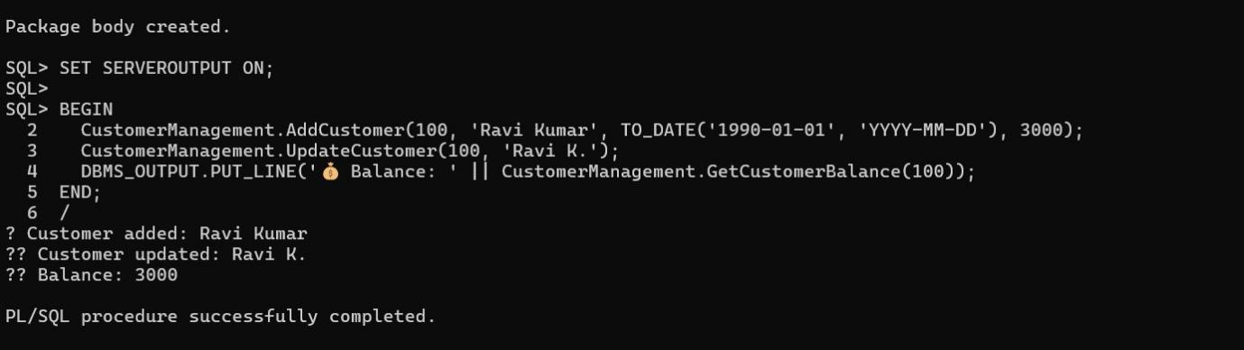

**Scenario:2**

**Pacakage specification**

CREATE OR REPLACE PACKAGE EmployeeManagement IS

PROCEDURE HireEmployee(p_ID NUMBER, p_Name VARCHAR2, p_Position VARCHAR2, p_Salary NUMBER, p_Dept VARCHAR2);

PROCEDURE UpdateEmployee(p_ID NUMBER, p_Salary NUMBER);

FUNCTION GetAnnualSalary(p_ID NUMBER) RETURN NUMBER;

END EmployeeManagement;

/

**Package Body**

CREATE OR REPLACE PACKAGE BODY EmployeeManagement IS

PROCEDURE HireEmployee(p_ID NUMBER, p_Name VARCHAR2, p_Position VARCHAR2, p_Salary NUMBER, p_Dept VARCHAR2) IS

BEGIN

INSERT INTO Employees (EmployeeID, Name, Position, Salary, Department, HireDate)

VALUES (p_ID, p_Name, p_Position, p_Salary, p_Dept, SYSDATE);

DBMS_OUTPUT.PUT_LINE('✅ Employee hired: ' || p_Name);

END;

PROCEDURE UpdateEmployee(p_ID NUMBER, p_Salary NUMBER) IS

BEGIN

UPDATE Employees SET Salary = p_Salary WHERE EmployeeID = p_ID;

DBMS_OUTPUT.PUT_LINE('🔄 Employee salary updated.');

END;

FUNCTION GetAnnualSalary(p_ID NUMBER) RETURN NUMBER IS

v_Salary NUMBER;

BEGIN

SELECT Salary * 12 INTO v_Salary FROM Employees WHERE EmployeeID = p_ID;

RETURN v_Salary;

EXCEPTION

WHEN NO_DATA_FOUND THEN

RETURN NULL;

END;

END EmployeeManagement;

/

**OUTPUT:**

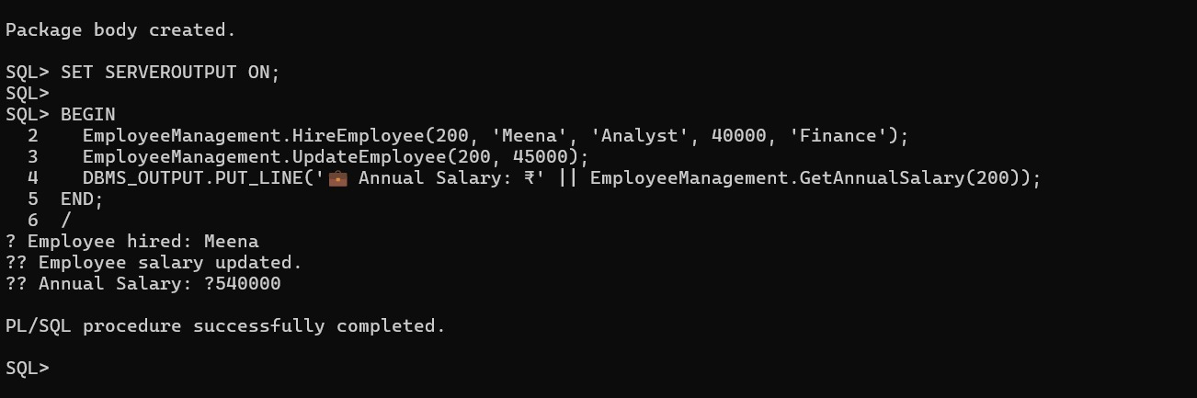

**Scenario:3**

**Package Specification**

CREATE OR REPLACE PACKAGE AccountOperations IS

PROCEDURE OpenAccount(p_ID NUMBER, p_CustomerID NUMBER, p_Type VARCHAR2, p_Balance NUMBER);

PROCEDURE CloseAccount(p_ID NUMBER);

FUNCTION GetTotalBalance(p_CustomerID NUMBER) RETURN NUMBER;

END AccountOperations;

/

**Package Body**

CREATE OR REPLACE PACKAGE BODY AccountOperations IS

PROCEDURE OpenAccount(p_ID NUMBER, p_CustomerID NUMBER, p_Type VARCHAR2, p_Balance NUMBER) IS

BEGIN

INSERT INTO Accounts (AccountID, CustomerID, AccountType, Balance, LastModified)

VALUES (p_ID, p_CustomerID, p_Type, p_Balance, SYSDATE);

DBMS_OUTPUT.PUT_LINE('🏦 Account opened: ' || p_ID);

END;

PROCEDURE CloseAccount(p_ID NUMBER) IS

BEGIN

DELETE FROM Accounts WHERE AccountID = p_ID;

DBMS_OUTPUT.PUT_LINE('❌ Account closed: ' || p_ID);

END;

FUNCTION GetTotalBalance(p_CustomerID NUMBER) RETURN NUMBER IS

v_Total NUMBER;

BEGIN

SELECT SUM(Balance) INTO v_Total FROM Accounts WHERE CustomerID = p_CustomerID;

RETURN v_Total;

EXCEPTION

WHEN NO_DATA_FOUND THEN RETURN 0;

END;

END AccountOperations;

/

**OUTPUT:**

